Hammerwich Parish Council
Appendix to Council Meeting (21 October 2026)

Agenda #7: Planning Application
Application Number | Location | Proposal | Link to documents on LDC website | Consultation deadline
26/01226/COU - (Change of Use) | Long Field , Land East Of High Ash Grange, Meerash Lane, Hammerwich | Change of use of agriculture land to a secure private hire dog exercise field  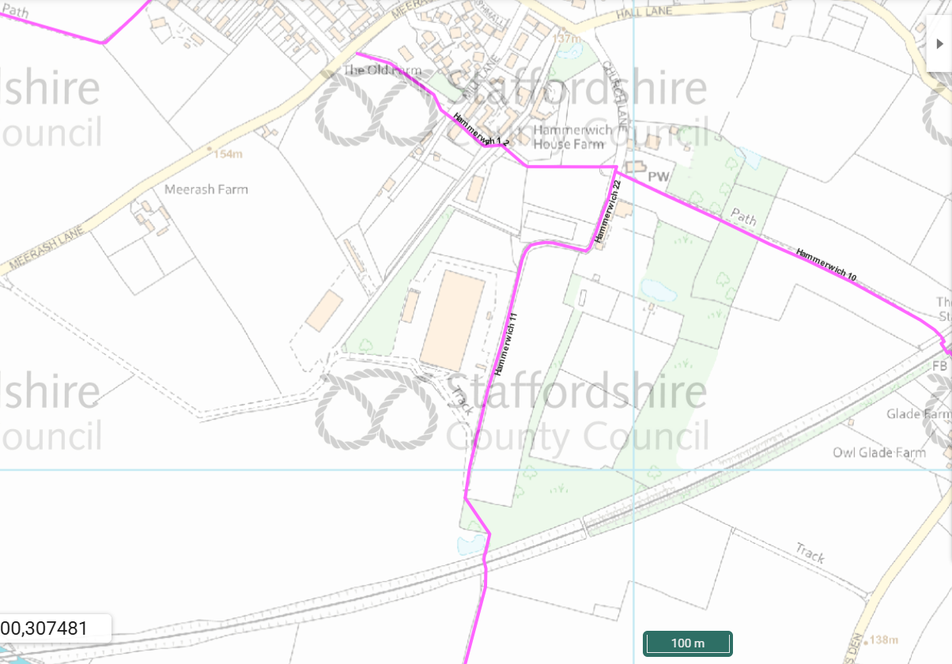  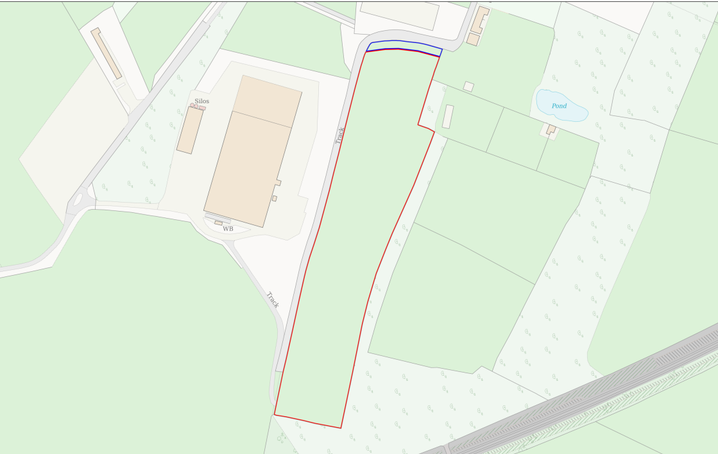  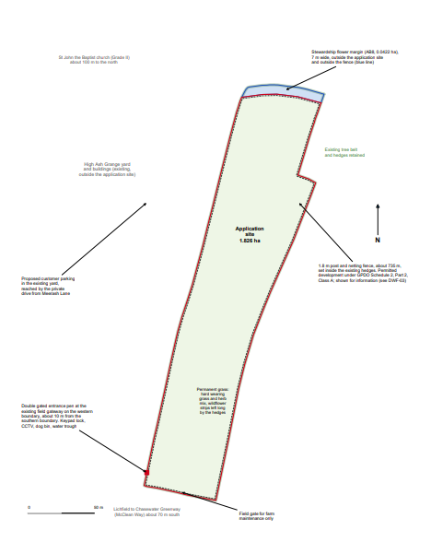 | https://planning.lichfielddc.gov.uk/online-  applications/applicationDetails.do?activeTab=documents&keyVal=TMJKBAJEN3Z00 | 3/11/2026

Other agendas:
Agenda # | Topic | Details
3. | Approval of minutes of last meeting held on 16 September 2026 | 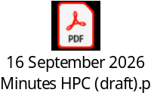
4. | Matters Arising | -
5. | Chairman’s Announcements | -
6. | County/District/Police Reports (if present) | -
7. | Planning Application | Refer to section 1 of this document.
8. Local Panning | 8.1 To receive report from Greenbelt Monitor Committee | To be updated by Cllr King
 | 8.2 To respond to LDC Local Plan and Call for Sites | 1. Loacl Plan:  A draft response letter was prepared by some councillors, however, it didn’t fit neatly into the 16 specific questions set out in the consultation. The draft points prepared by the Council didn't really fit neatly into these 16 questions. The Council to review and confirm if to send it directly to Cllr Farrell.    2. Cllr King and Cllr Turnbull to share update regarding Call for Sites.  Call for sites  The new Local Plan will allocate sites to meet development needs. We are inviting submissions of land which may be suitable for uses such as housing (at least 5 homes), Gypsy and Traveller sites, employment, retail, sports, community or other uses. We are particularly keen to hear about brownfield (previously developed) land and you can suggest these sites even if you are not the landowner as the Council will investigate further. However, submission of a site does not guarantee that it will be selected for development through the Local Plan.  Even if you have submitted the site previously, the new online form must be filled in for the site to be considered. The call for sites will be open for a longer period to allow more time to prepare submissions from 7th September to 30th November 2026.  For more information on the Call for Sites specifically please follow this link - Call for Sites 2026  Queries about the consultation  Please contact the planning policy team if you have any questions or require further information or assistance. You can also request not to be contacted about the Local Plan in future.  Contact us directly by email developmentplans@lichfielddc.gov.uk or WhatsApp us on 01543 308171. Alternatively, you can call 01543 308000 and ask for planning policy.  https://lichfielddc-consult.objective.co.uk/kse/userdetails  
 | 8.3 To respond to Walsall Borough Local Plan (WBLP) Regulation 19 Consultation | Walsall Borough Local Plan (WBLP) Regulation 19 Consultation  From the 21 September 2026 to the 2 November 2026, residents and businesses can have their say on whether they believe the Local Plan has been prepared correctly and whether it meets the national tests required for approval. The plan can be viewed online and in local libraries.  Alongside an online consultation process through Commonplace, interested parties are also invited to the following events:  - Tuesday 29 September 2026: online event  6pm, Register via Eventbrite  - Wednesday 14 October 2026: in person consultation event  5.30pm at Walsall Town Hall  Register via Eventbrite  The events will consist of a presentation about the Local Plan and a Q&A with the council’s planning team, as well as the opportunity to find out how to make a representation on this latest consultation phase. The events are free to attend and open to all, booking via Eventbrite is essential.  For more information about the local plan, and Regulation 19 consultation, visit the Walsall Borough Local Plan Commonplace page.  If you have any queries, please contact us via WBLP@walsall.gov.uk  If you need the information in an alternative format, i.e. Easy Read, large text, audio, or a community language, please email wblp@walsall.gov.uk or call 01922 650000.  Planning Policy  Walsall Council
9. Council Admin | 9.1 To receive update on council office set-up at the HYCC and approve relevant expenses | - Free work desk and cabinet sourced and moved in.  - Production of outdoor signage in progress.  - Office printer ordered at £74. Various office supplies to be ordered: fire extinguisher, stationeries etc
 | 9.2 To consider the opening ceremony of the council office | To consider the date/time for holding the ceremony before next Council meeting takes place at the HYCC.
 | 9.3 To approve the asset register 2026/27 | 
 | 9.4 To approve the insurance renewal of the Council | Insurance amount for 2026/27 is £1,340.30  
10. Highways & Footpath | 10.1 To receive update of the SIDs repair | To receive latest update following one of the SIDs shipped back to the supplier for further checking in September.
 | 10.3 To consider drain clearance plan for the village | To review the drainage situation in the village and consider if any drain clearance funded by HPC is needed.  Cleanse schedule by SCC:  Biennial, next due 29/4/2027  - Coppice Lane  Triennial, next due 25/3/2028  - Hall Lane  - Meerash Lane  - Hammerwich Lane  - Stockhay Lane  - Burntwood Road  - Church Lane  - Middleton Close  Triennial, next due 8/4/2028  - Hammerwich Road  - Overton Lane  - Pingle Lane  - Norton Lane  Triennial, next due 6/5/2028  - The Ridgeway  Proposal from Councillors:  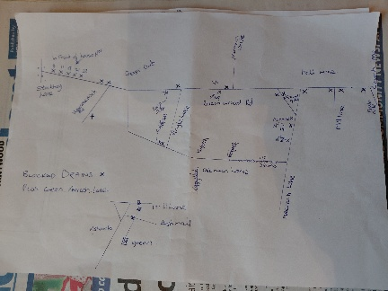 (Cllr Ubhie)
11. Parks and Open Spaces | 11.1 To consider replacing the wooden play equipment at Mansion Drive Park | LDC advised that they don’t have this available in composite. The Council to consider if to accept timber at the below cost.  ===  The wooden equipment at the park is damaged and need replacing.  To remove and dispose of the existing play apparatus, supply new timbers and construct a new play enclosure using 4” timbers, total cost £1360 + vat.  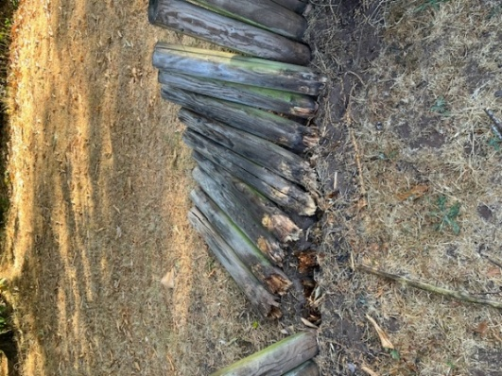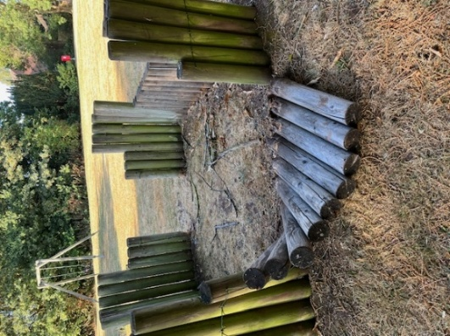
 | 11.2 To respond to the complaints about trees at Oakfield Park | 2 complaints received so far.  - 22 Blackthorne Ave: complain about dropping chestnut shells and the branch of council’s tree helped the squirrels gained access to their loft.  - 19 Copthorne Ave: complain about the branches are growing over his fence, and the branches are falling off the trees due to some of the trees dying due to Ivy. He is worried about the fire risk, and he has asked for an onsite meeting.  An urgent inspection of the trees adjacent to these two properties are carried out, all trees confirmed no health and safety concern. Only a tree further away requires attention due to deadwooding. Now waiting for quotation of the work from LDC.  Meanwhile, HPC has replied with the following:  Email replied to resident at 22 Blackthorne Avenue:  ===  Thank you for your further email regarding the trees in Oakfield Park. I am sorry to hear about the problems you have been experiencing, particularly the discovery of squirrels in your loft. I appreciate that this is understandably concerning for you and your family. The Parish Council has also noted your concerns about falling debris.  For context, HPC is aware that an official complaint concerning the trees adjoining 22 Blackthorne Avenue was investigated by Lichfield District Council in 2024. At that time, LDC confirmed that the trees were being maintained in accordance with its tree policy and that the tree inspection report had identified no health and safety issues. The investigation also considered concerns about falling chestnut shells and leaves blocking gutters, noting that seasonal leaf fall is generally outside the tree owner's control.  HPC recognises that the condition of a tree can change over time. In view of your concerns, the Parish Council will arrange for the specific tree to be inspected by its appointed arborists, to ensure that its condition is assessed and to establish whether there are any health and safety concerns requiring attention. This will be undertaken in line with the Council's existing tree inspection arrangements with Lichfield District Council.  For concerns beyond tree health and safety, including the overhanging branches on your property, the Council's position is that residents may generally cut back branches to their property boundary, subject to any applicable tree protection requirements and ensuring that the work does not unlawfully damage the tree.  If you believe the overhanging branches are facilitating squirrel activity around your property, you are free to consider cutting them back to your boundary, subject to these requirements. However, HPC is not in a position to confirm whether the branches are contributing to the squirrel problem, nor does the Council endorse conclusions made by a private service provider. Any decision regarding tree works on health and safety grounds will be informed by the advice of the Council's appointed arborists.  Thank you for bringing your concerns to the Parish Council's attention. We trust that the inspection will help establish whether any action is necessary to address health and safety concerns relating to the tree.  Best regards,  Hammerwich Parish Council  Email from 22 Blackthorne Avenue:  ===  Good morning,  We have now received information from Lichfield District Council advising us to contact Hammerwich Parish Council directly regarding the complaint raised in my previous email.  I would like to provide further information, as the situation has now escalated considerably and requires urgent attention.  Following my previous reports regarding the ongoing issues caused by the trees overhanging from the public park, Pestforce has attended my property to investigate the noises coming from the loft space.  During their internal inspection, it was confirmed that squirrels have gained access to the loft and have been attempting to establish a nest. Chris from Pestforce subsequently carried out an external inspection and identified the likely point of entry. He has advised that, in his professional opinion, the trees are effectively providing a bridge from the park into our property, allowing the squirrels to gain access to the roof and subsequently the loft space.  This is extremely concerning. What initially involved the risk of falling debris, including an incident where I was struck on the head by a falling husk, has now developed into an active squirrel infestation within the loft of our family home.  I am therefore extremely concerned that the ongoing failure to address the overhanging trees and associated access route from the public park has directly contributed to the current situation.  I would ask that Hammerwich Parish Council urgently investigates this matter and liaises with the relevant authority or landowner responsible for the trees to ensure that appropriate action is taken. I would also appreciate confirmation of what steps will now be taken to prevent further access to our property and address the underlying cause of the problem.  Given the escalation from a safety concern involving falling debris to an active pest infestation within our home, I would ask that this matter is treated as a matter of urgency.  I look forward to receiving a prompt response confirming the action that will be taken.  ===
 | 11.3 To consider including tree belt maintenance in the ground maintenance schedule | Since regular tree belt maintenance was removed from LDC’s grounds maintenance contract in 2024, the Council appears to have received an increasing number of tree-related complaints.  Regular strimming and lifting of low-hanging branches would help keep the tree belts tidy, improve the overall appearance of the park and make the area more pleasant for residents to use. Covering Oakfield, Triangle, and Mansion Drive Parks.  The last time we carried out the strimming and lifting of the branches to the tree belts on Area A and Area 6 I believe was back in 2023-24 at a cost of £1511.33.  With the annual increases that would have been applicable should this work have continued and the rate for this year would equate to £1704.40 +vat.
 | 11.4 To receive the ROSPA inspection reports | Annual inspection of play areas by ROSPA completed with no major risks identified.  
 | 11.5 To receive update on the adverse possession of land on Meerash Lane, and approve action and costs (if applicable) | 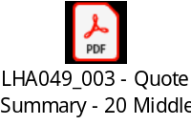  Land Registry has advised that Hammerwich Parish Council previously lodged an adverse possession application on 20 April 2014. That application was cancelled after Staffordshire County Council confirmed that the land was highway maintainable at public expense. I was not previously aware that an application had been made in 2014.  Land Registry now requires evidence showing that this is no longer the position before the current application can proceed.  If you wish to explore challenging the position, we would need to obtain a highways search. Please find the quotation attached. The search should either confirm the recorded highways status or provide information which may support a challenge. We can then assess the results and advise on the appropriate next steps.  Land Registry has stated that it will hold the application until 30 October 2026. If it has not received the required additional information by that date, it will cancel the application and refund the fee.
12. Churchyard | 12.1 To receive update on Churchyard transfer | Diocese Registry confirms that they are unable to advise as to any maintenance agreements with the council as this falls outside the scope of the retainer we hold with the Diocese however your Archdeacon may be able to provide comment.  HPC has then written to the Archdeacon asking for indemnity insurance to be arranged instead but haven’t heard any update yet.  ===  Dear Archdeacon Weller,  Hope you are well. I'm writing on behalf of Hammerwich Parish Council (HPC) in regard to the transfer of churchyard responsibility of St. John Baptist Church, Hammerwich.  The Parish Council has been awaiting clarification on the outstanding repairs to the churchyard and the possibility of reaching an agreement with the Diocese regarding future maintenance responsibilities. However, following the response from the Diocesan Registry that this matter falls outside the scope of its retainer with the Diocese, the Council remains without a clear resolution.  As the Diocese has not yet fulfilled its outstanding obligations in relation to the churchyard repairs or reached an agreement with HPC, the Council is unable to accept responsibility for the maintenance of the churchyard at this stage.  Nevertheless, HPC remains willing to reconsider the transfer, provided that the Diocese arranges appropriate indemnity insurance to address the outstanding matters and potential liabilities associated with the churchyard. The Council would require a copy of the insurance documentation for review before considering whether the transfer could proceed.  We hope this proposal will provide a practical way forward, enabling both parties to resolve the outstanding issues and reach a mutually acceptable arrangement.  We would be grateful for your comments and assistance in progressing this matter towards a resolution. Thank you.  ===
 | 12.2 To receive and consider the letter submitted by the neighbour | A letter from the neighbour of the Churchyard, The Church Cottage, has reached the Council. The Church Cottage has a boundary wall with the churchyard which the Council didn’t request to inspect as it is owned by the neighbour.  Following the Council’s July meeting and upon reviewing the structure inspection report, the owner of The Church Cottage requested the attached letter be presented at the coming parish council meeting.  A reply had been sent to him on behalf of the council, explaining the situation and inviting him to attend our meeting.  As the Structural Inspection report has included his property boundary wall without prior consent, it has been immediately removed from the Council website.  The Council to decide:  - Whether to redact all contents relating to the "Church Cottage" and re-upload the report.  - Whether to amend the 15 July 2026 meeting minutes as per the request of the neighbour. Please note that only general term “boundary walls” was mentioned in the minutes, nothing in specific about this particular neighbour.  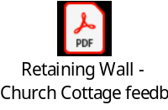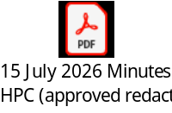  Further communication received from the neighbour on 20th October 2026:  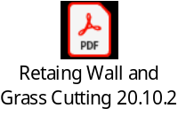
13. | Correspondence received and sent | Correspondence received and sent - October 2026
14. | Accounts for Payment | Account for Payment - 21 October 2026  Bank statements:    Bank conciliation (as of 30 September 2026):    Budget Monitor – October 2026: here
15. | Public Participation | -
16. | Items for discussion at the next meeting | -
Prepared by: Vivien Wang (Parish Clerk)
Date: 16th October 2026
- End of Report -

