Hammerwich Parish Council
Appendix to Council Meeting (15 July 2026)

Agenda #8: Planning Application
Application Number | Location | Proposal | Link to documents on LDC website | Consultation deadline
Nil pending consultation | - | - | - | -

Other agendas:
Agenda # | Topic | Details
3. | To fill vacancies on the council by co-option | Mr Paul Smith had spoken to the Council. At this meeting, his 3rd attendance at a full council meeting, the Council will vote on his co-option.
4. | Approval of minutes of last meeting, and note minutes of annual parish meeting held on 20 May 2026 | 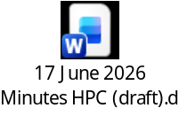
5. | Matters Arising | -
6. | Chairman’s Announcements | -
7. | County/District/Police Reports (if present) | -
8. | Planning Application | Refer to section 1 of this document.
9. | To receive report from the Greenbelt Monitor committee | To be updated by Cllr King
10. | To receive update of the SIDs repair | The SIDs are expected to be returned to us by this week. Will secure manpower to put them back on; or get LDC to install for us at a fee.
11. | To receive the notice of Churchyard closure and decide follow-up | Churchyard closure notices:    On 30th June 2026, the Council was notified by Revd Morgan (by personal visit to Chair), followed by Sylvia Lindley that the churchyard was closed. However, the Council was not informed of the closure officially by the MoJ.  In response, the Council has drafted this letter to clarify Council’s position and provide details about what maintenance and repair are expected before the transfer of responsibility. The full inspection reports on structure and tree will be enclosed to this letter.  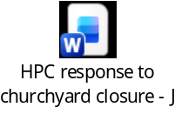
 | Churchyard – structure inspection report | Main items of concern for maintenance:  - The wall along Church Lane leans towards the road by up to 6.5o out of plumb maximum. No imminent danger of collapse, and only limited remedial actions possible.  - The bowing and extensive cracking to the boundary wall within an outbuilding of the Old is similarly difficult to remediate.  - The brick wall section at the NE corner of The Old Rectory garden has partially collapsed and is leaning on either side.  - In conjunction with item 3 the trees and undergrowth are causing problems along boundary walls, especially with masonry walls that will have shallow foundations.  - The ownership of the retaining wall at the south boundary with Green Fields was unclear. Sections of the top have collapsed with vegetation growth.
 | Churchyard - tree inspection report | 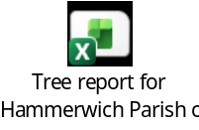  From the tree inspector:  ===  Hi Andy  These trees are all in now, 155 in total. This is due to me adding in some more of the group trees as we spent a bit of time on the area the Church Wardens had brought to our attention.  Recommended maintenance includes:  Some items of general maintenance, removal of dead wood and crown lifting where branches are over paths.  Ivy management - quite a few of the trees are Ivy covered, and though it is beneficial for wildlife, on some of the trees where the Ivy extends into the crown and prevents a full inspection this is recommended for removal.  The area adjacent to the Old Rectory - there is a hedgerow with some mature trees within it. Several of the mature trees are recommended for Ivy management, and the whole area could benefit from some further Ivy management and clearance as it has become overgrown.  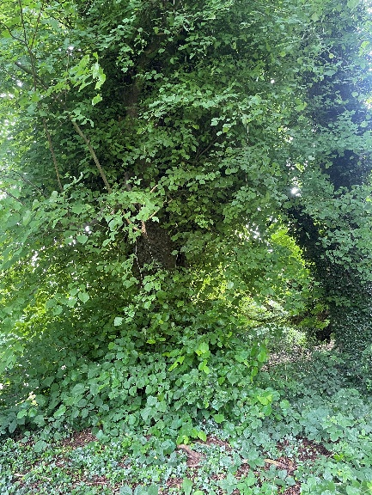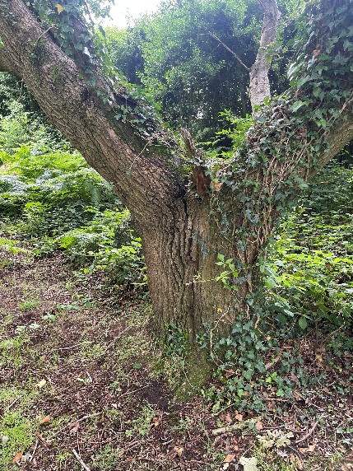  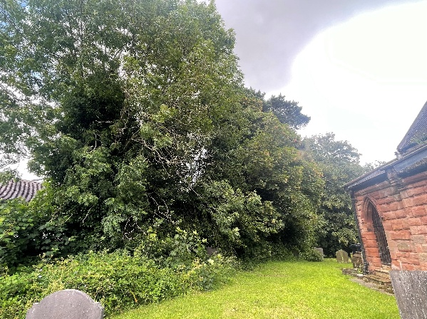  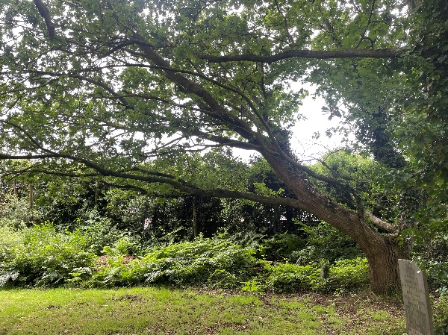
12. | To receive update on council office set-up at the HYCC | No progress from HYCC as their July meeting was not quorate.  A draft agreement (as attached) was received from HYCC but the Council is in disagreement to the following terms. Hence, it is not ready for council’s approval.  - Hammerwich Parish Council will have responsibility for the maintenance and repair of the building and surrounding car park and will be known as the custodians. The Centre will remain vested in the Community  - The use of the car park will be the responsibility of the Parish Council.  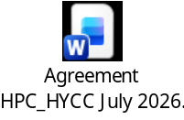
13. | Correspondence Received and Sent | Correspondence Recevied and Sent - July 2026
14. | Accounts for payment, Bank Reconciliation, Budget Monitoring |   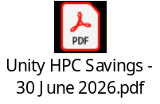    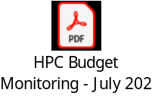
15. | To approve the executive power during Council recess | For approval as no Council meeting in August
16. | Public participation | -
17. | Confidential: HR matters | To be updated by Employment Committee
18. | Items for discussion at the next meeting

Prepared by: Vivien Wang (Parish Clerk)
Date: 11th July 2026

- End of Report -

