Hammerwich Parish Council
Appendix to Full Council Meeting (17 December 2025)

Agenda #7: Planning Application
Application Number | Location | Proposal | Link to documents on LDC website
Nil

Other agendas:
Agenda # | Topic | Details
8/1 | To approve the call-out service of SID engineering check | Cllr King is discussing with the technical team of the supplier, hoping to resolve the issue without a call-out. Further update to be provided at the meeting.
8/2 | Consultation - Proposed Diversion of Footpath No.11 Hammerwich | Notice received from SCC re the consultation  Staffordshire County Council is currently considering an application to divert the above public footpath. The effect of the diversion will be to extinguish the existing section of footpath shown by a solid black line (A-B) on the map and create in its place the footpath shown by a broken black line (A-C-B). The proposal will not result in any physical changes on the ground but will regularise the route that has been the preferred route used by the public for many years. Reinstatement of the Definitive line, which has not been used for some time, will necessitate the removal of some mature vegetation and trees. Improvements will be made to the wet section of the proposed route to make it better for walkers. The proposed new route will have a width of 1.5 metres and will be a highway maintainable at public expense.  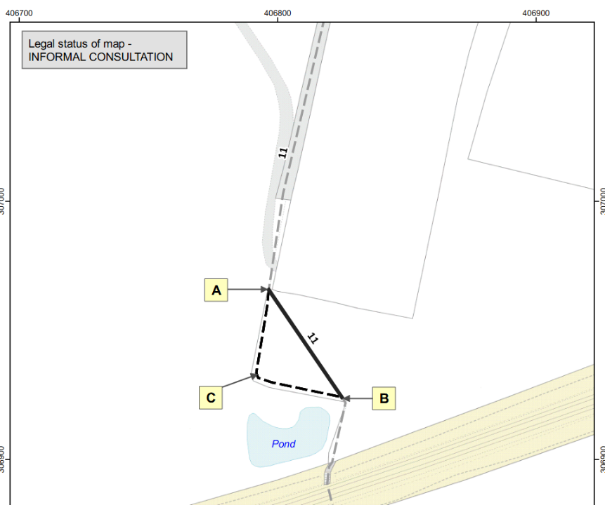
9 | Report for resident survey | Highfields Road land development (Online survey responses).xlsx  - 334 responses received; any paper survey received in the future will be added to this summary.
10 | To approve Precept 2026/27 | Enclosed please find the proposed Precept 2026/27 for your preview.  Based on this year's actual spending, I've worked out two proposals, whereas the higher one (+13.8%) allows 2x notice boards instead of 1x. The budgets for finger post upkeep, SID batteries replacement and drain clearance are slightly higher in this higher proposal.  - £36,750 (+8.1% v.s. LY £34K) [+£1.70 / +6.92% in Council Tax Band D]  - £38,700 (+13.8% v.s. LY £34K) [+£3.09 / +12.6% in Council Tax Band D]  A summary for current year (2025/26), the Council is expected to have spent £37K by end March even though the precept was £34K only. The factors for the overspent are listed as below. The overspent was partly offset by the income we received (donations, bank interests etc).  - Trainings, incl. whole council in-person training, Clerk's CiLCA training  - Staff cost to support the extra hours of Clerk's CiLCA training  - Open space management (hedge cutting, fence repair, bush trimming, tree removal) more than planned  Please let me know if anything is unclear. Thank you.
11 | To adopt an IT policy | Proposed IT Policy for approval:  Background:  There is a new requirement in the Council's Annual Governance Statement this year. The Council must confirm they are digital and data compliant.  Councils are required to deliver in the 5 areas below (see the ticks). HPC is sorted with areas 1 and 2, and Agenda #11 this month is aimed to fulfill area 5 - Use of IT equipment & software.  Making use of the template policy from NALC, a draft IT Policy is proposed (as attached) for approval at the coming meeting.  p.s. Area 3 & 4 (FOI & Transparency, and Data Protection) will be looked into and dealt with at the following meetings if required.  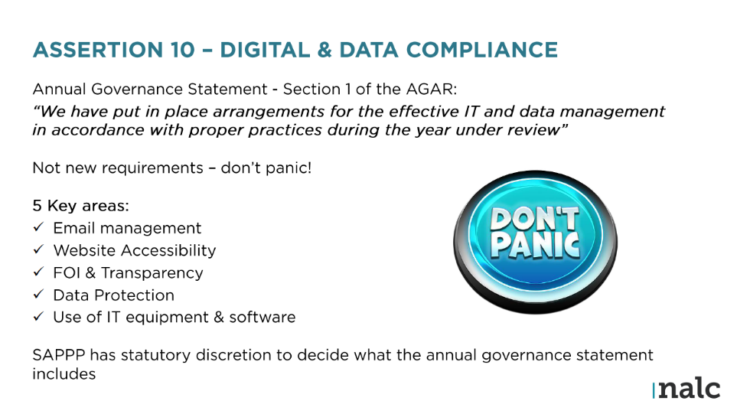
12 | To approve subscription to Support Staffordshire | Annual subscription fee £25:  As the Rural Community Council for Staffordshire and the local ACRE (Action with Communities in Rural England) Network member, Support Staffordshire offer an additional rural-focused service on-top of our general member services to rural community groups such as village halls and community shops.  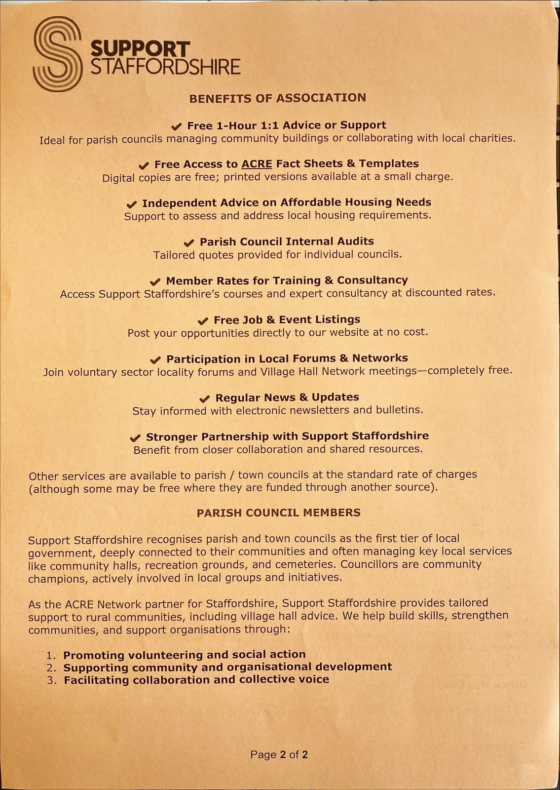  Support Staffordshire is made up of the following members:  - Start-up Members  - Local Community Group and Charity Members  - Local Social Enterprise Members  - Associate Members  - Parish/Town Council Members  - Volunteering For All Members
13 | To approve subscription to Mapping Servies | Will postpone this agenda to the January meeting as it takes time to familiar with the platform trial before presenting to the full council.
14 | Correspondence Received and Sent | To be shared separately
15 | Accounts for payment | Shared separately
16 | Public participation | -
17 | Items for discussion at the next meeting | -

- End of Report -

