Hammerwich Parish Council
Appendix to Full Council Meeting (19 November 2025)

Agenda #7: Planning Application
Application Number | Location | Proposal | Link to documents on LDC website
25/01428/FUH | 12 Brooklyn Road, Burntwood | Retention of flat roof to rear and erection of a single storey side extension | https://planning.lichfielddc.gov.uk/online-applications/applicationDetails.do?activeTab=summary&keyVal=T5O1WEJE0PO00
25/00907/LBC - (Listed Building Consent) | 79 Overton Lane | Works to listed building to enable alterations / remodelling of existing garage roof creating room within void and single storey rear extension | https://planning.lichfielddc.gov.uk/online-applications/applicationDetails.do?activeTab=summary&keyVal=SZQM95JEHKA00
25/00906/FUH | 79 Overton Lane | Alterations/remodelling of existing garage roof creating room within void and single storey rear extension | https://planning.lichfielddc.gov.uk/online-applications/applicationDetails.do?activeTab=summary&keyVal=SZQM8PJEHK800
25/00450/FUH | 12 Sedgemoor Avenue, Burntwood, | Double storey rear extension and side first floor extension, with pitched roof added to  porch | https://planning.lichfielddc.gov.uk/online-applications/applicationDetails.do?activeTab=summary&keyVal=SUGDNCJEFMC00
25/01444/FUH | 13 Paviors Road | Single storey rear extension and new window/window alterations to front of property | https://planning.lichfielddc.gov.uk/online-applications/applicationDetails.do?activeTab=summary&keyVal=T5XF0SJEKU300

Other agendas:
Agenda # | Topic | Details
8/1 | Application to the Community Paths Initiative Fund | Summary: To discuss community path projects that to be submitted for the funding application.  Community paths initiative fund - Staffordshire County Council  The Staffordshire Community Paths Initiative (CPI) provides funding for projects to improve or promote countryside access through rights of way.  - Grants of up to £2,000 are available, with the Community Paths Initiative match funding up to 50% of the total costs. Contributions from Staffordshire County Council greater than 50% will only be considered in exceptional circumstances.  - Parish or Town Councils, landowners, community or residents groups, and user or interest groups can apply.  - CPI can fund projects that deliver at least one of the following:  - Projects that focus on routes or issues that provide benefit to residents, visitors and the local economy.  - Projects that have been developed in response to local needs and/or through working with others.  - Projects that overcome seasonal or long-standing issues.  - Projects that provide information on finding paths and using them responsibly.  - Projects that provide a long-term benefit to the local community, beyond the funding period.  What can the CPI fund?  - The CPI seeks to fund projects that deliver at least one of the following:  - Typical projects include:
  - Projects that focus on routes or issues that provide benefit to residents, visitors and the local economy.
  - Projects that have been developed in response to local needs and/or through working with others.
  - Projects that overcome seasonal or long-standing issues.
  - Projects that provide information on finding paths and using them responsibly.
  - Projects that provide a long-term benefit to the local community, beyond the funding period.
  - Path Surfacing | - | Improve drainage or apply new surface material.
  - Vegetation Control | - | Clear encroaching vegetation by bidding for strimmers, bushcutters, PPE, etc
  - Replacing stiles with gates | - | Improve access for disabled users, those with limited mobility and users with pushchairs and young children.
  - Installation of a boardwalk or bridge | - | Provide access across a boggy area or a crossing over a ditch or stream.
  - Benches | - | Install additional benches, especially where there is a vista.
  - Mapboards and leaflets | - | Encourage access to the countryside with professionally designed leaflets or mapboards promoting local walks.
  - Signage | - | Good signage gives the public confidence that they are using the correct route and avoids inadvertent trespass.
8/2 | Update on the fingerpost improvements | 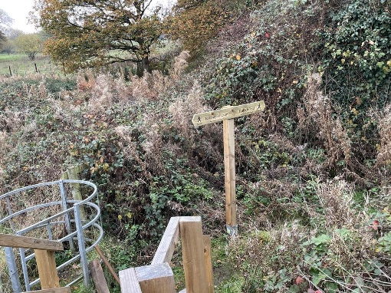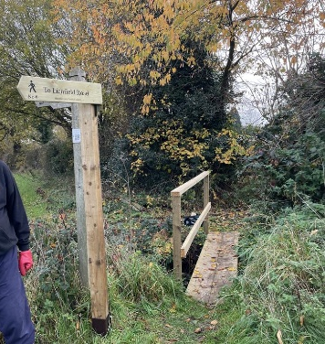
9/1 | To discuss follow-up on Asset Transfer from LGR | HPC was informed that the LDC had set out a CAT (Community Asset Transfers) Policy in June 2025 in the context of LGR. Burntwood Dragons FC (Coppy Nook) was mentioned in the press release.  According to this policy, a Parish Council could initiate a CAT for LDC to consider. It is stated that “10. If there are a number of organisations interested in taking on an asset available for transfer, the council will initially aim to encourage collaboration. However, if this is not possible a competitive process will be used to decide the outcome and the successful organisation will become the preferred partner in the transfer process.”  Chair and the Clerk had an initial discussion and proposed raising CATs for 1) Coppy Nook land; and 2) Oakfield Park.  For Council’s discussion and approval:  - Raising CAT for the above mentioned (either one or both) lands, in which a comprehensive study have to be started as a business plan might be required.  - Any other assets that are targeted for a CAT?
9/2 | To appoint a representative to Burntwood Dragons FC | Chair has been in touch with Burntwood Dragons and touched on appointing a council delegate there. While details of the appointment is to be worked out, could the Council initially discuss the preferred representative?
10 | Key projects for Precept 2026/27 | Improving the communication with parishioners are important. Initial proposal for upcoming new projects:  - Council owned notice boards x 2 to improve communication with parishioners – one at the Triangle Ward, one at the Hammerwich Ward
11 | Update from Burntwood Masterplan workship | To be updated by attending councillors at the meeting.
12 | List to be submitted to Clean and Green scheme | This is the list
   | Proposed projects | Estimate budget
  1 | New finger posts upgrade for greenway | £500
  2 | Dog bins Mansion Drive | From £430
  3 | Two notice boards on Council land | From £900 x 2
  4 | Welcome to Hammerwich sign at the access point x 3 (check with Dave on signs) | From £250 x 3
  5 | Hammerwich sign - Hospital Road/Coppy Nook --> frequently being knocked. Move to safer corner place | From £250 (tbc)
  6 | Hedge cutting at Meerash Lane green | From £500
  7 | Wooden bus shelter on the Burntwood Road ,it needs some TLC .ie painting and it could be made a focal point of the village | From £300 (tbc)
  8 | Planters on the two islands one on pingle Lane and the other at the bottom of the Church lane. | From £500 x 2
  9 | The Sign pointing for Hammerwich has broken off on the Walsall Road towards Coppice Lane . | From £250 (tbc)
  10 | Clear on manhole on Meerash Lane | From £1,200
  11 | Kissing gate at the entrance of footpath at Paviors Road | From £500
13 | Survey regarding land development off Highfields Road | - 20x A2 and 20x A3 poster printed. Printing cost £150 (ex-VAT) for approval.  - Announced the survey on website and facebook  - As of 5pm on 17th November, 11 responses were received.  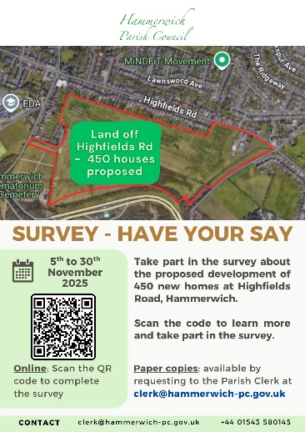
14 | Correspondence Received and Sent | To be shared separately
15 | Accounts for payment | To be shared separately
16 | Public participation | No update
17 | Items for discussion at the next meeting | - Approval of Precept  - Adoption of an IT Policy to comply with new requirement in AGAR Assertion 10 of 2025/26  - Community Path fund application  - Community Asset Transfer (CAT) by HPC

- End of Report -

