Hammerwich Parish Council
Appendix to Full Council Meeting (17 September 2025)

Agenda #7: Planning Application
Application Number | Location | Proposal | Link to documents on LDC website
25/00767/FUL  (consultation expired) | Ridgeway Primary School Grange Road | External works to create play area, including retaining wall and landscaping | https://planning.lichfielddc.gov.uk/online-applications/applicationDetails.do?activeTab=documents&keyVal=SY3TKDJEGYW00
25/00941/FUL - (Section 73)  (consultation expired) | Pipe Hill House, Walsall Road | Section 73 application to permission of 20/00295/FUL to remove condition 2 to  change the proposed roof shape and covering | https://planning.lichfielddc.gov.uk/online-applications/applicationDetails.do?activeTab=summary&keyVal=T041IZJEHPR00
25/01069/FUH | Malvern House, 12 Pingle Lane | Two storey rear and side extensions to form bedroom, open plan kitchen / living room / diner and creation of parking area and associated works | https://planning.lichfielddc.gov.uk/online-applications/applicationDetails.do?activeTab=summary&keyVal=T1N92BJEI9R00
25/00915/FUL | Gartmore Riding School, Hall Lane | Installation of two shipping containers and curved canopy roof between them | https://planning.lichfielddc.gov.uk/online-applications/applicationDetails.do?activeTab=documents&keyVal=SZSGYIJEHLB00
25/01102/FUH | 1 The Tanyard, Ashmall Farm, Mill Lane | Erection of garden room (golf simulator) | https://planning.lichfielddc.gov.uk/online-applications/applicationDetails.do?activeTab=summary&keyVal=T23SUYJEIK100

Other agendas:
Agenda # | Topic | Details
8/1 | To approve the purchase of replacement batteries for SID #2 | The battery of SID #2 is approaching its end of life. It is proposed the Council order a new set of batteries from the original supplier for replacement.  The cost is 173.95 (ex-VAT).
8/2 | To approve footpath maintenance collaboration with Back the Track | From Cllr King: “I met the back the track team on Monday, and they offered to help with the paths which cross the old railway line. Paths 9, 10 and 11. That would be a great help and could expand.”
8/3 | To approve the replacement of missing fingerpost | From Cllr King: “Finger post on path 6 has disappeared, it is probably in the drainage ditch. We could look at replacement through Collis and our engraver to save money. The old railway line should officially open later this year. With access points on paths 9, 10 and 11, we could look at extra signage to guide walkers onto our network, not onto farm land.”
8/4 | To approve the purchase of a trimmer and hedge cutter for footpath maintenance | From Cllr King: “I have been using my own power tools to keep the paths open for a few years now. The cordless strimmer does a good job on soft growth, but I have to use my long reach hedge trimmer to tackle brambles and ferns. It has limited work time due to the size of the batteries, and is a basic domestic tool, not heavy duty. It is also showing signs of wear.”  Cllr King proposed to purchase 1) Ryobi long reach hedge cutter; and 2) two rechargeable batteries for on-going footpath maintenance.  The estimated cost for a trimmer with branded batteries & charger is from £236.50 to £400.91 (4.0AH to 8.0AH).  The estimated cost for a trimmer with non-branded batteries & charger is £139.81.  Please see detailed breakdown as below:  - Hedge trimmer: £89.00 (ex-shipping) – no battery and charger  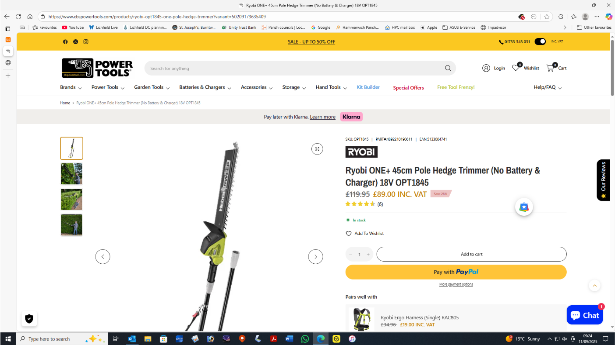  Link here  - 2x batteries and charger
  (Incl. VAT) | Batteries (2x) | Charger (1x) | Sub total (ex-shipping)
  Original Ryobi (8.0 AH) | £237.92  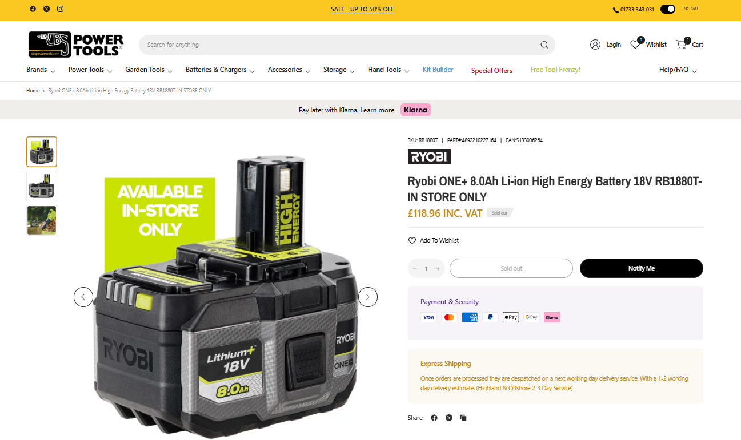  Link here | £73.99  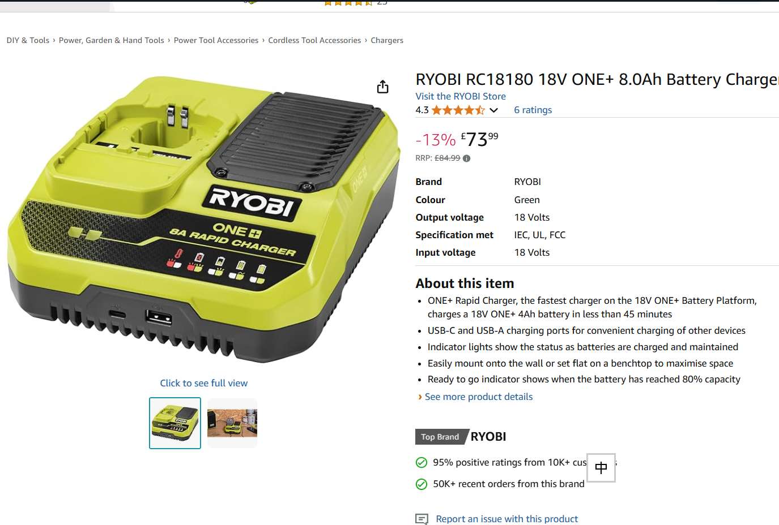  Link here | £311.91
  Original Ryobi (4.0 AH) | £147.50  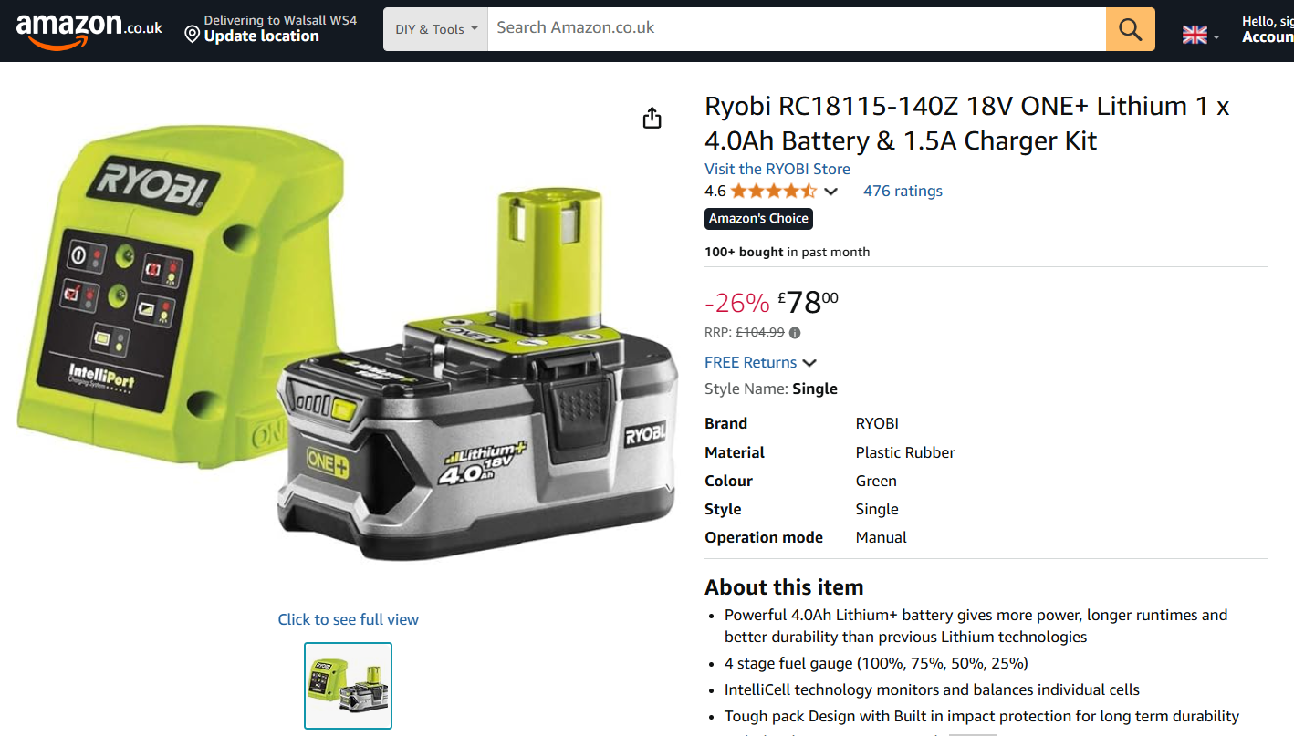  Link here  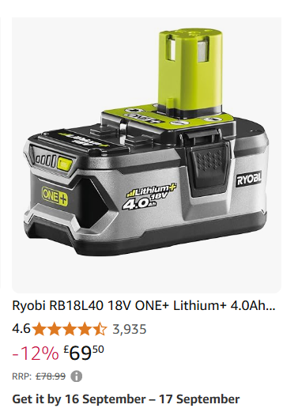  Link here |  | £147.50
  Non branded | £50.87  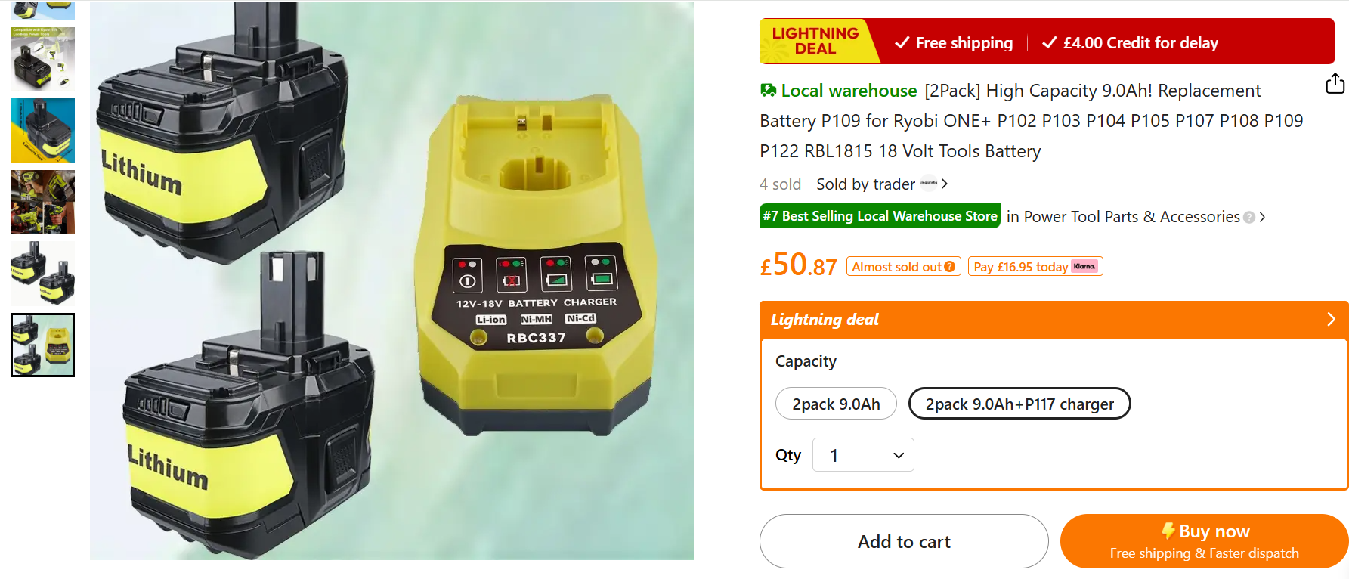  Link here |  | £50.87
9/1 | To approve replacing the damaged dog bin on Mansion Drive park | 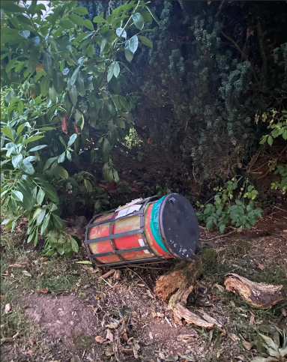  Email from LDC: “From what I can tell the bin doesn’t look like it was fixed into the ground very deeply and when the Team Leader arrived on site it was partially lying on the ground. He removed the bin from site as he considered this to be a potential Health and Safety issue.  The bin is emptied weekly and the bag from the last emptying is sitill in place with only one dog poo bag inside.  A new bin will be the same size as the dog waste bin on the other side of the park. I can’t remember the exact capacity but I think they are around 50ltr. I’m sure this along with the other dog waste bin will provide more than enough capacity for this area.  The cost to supply and install will be £400 + vat.”
9/2 | To respond to the complaint about bush overgrown opposite 57 Warren Road | A resident from 57 Warren Road had contacted HPC through LDC asking for a bush opposite to her house to be trimmed.  From LDC: “Resident has contacted LDC about an overgrown bush opposite her house on public land. She is concerned as the bush is attracting litter and people urinating on the area. This was logged with LDC in January but the parks team said this was the responsibility of Hammerwich Parish Council.”  p.s. The same request had reached HPC in January and the Council at that time had decided not to trim the then not overgrown bush.  The cost to trim back, and remove and dispose of the arisings will be £85 + VAT.  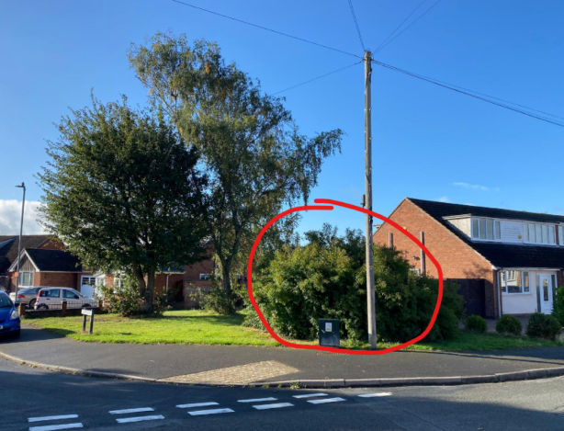  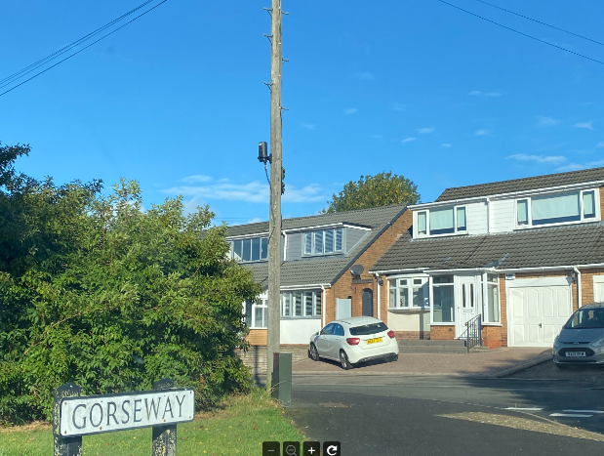  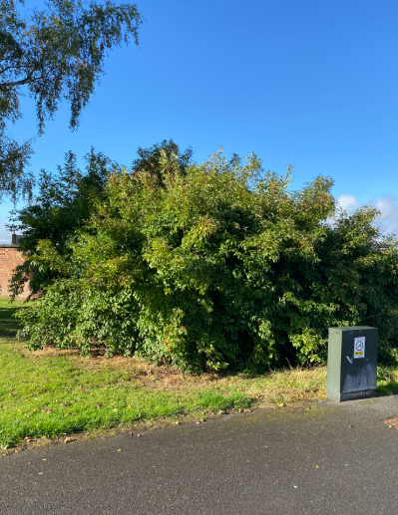
9/3 | To review the trial of dog exercise course in Triangle | - Installed in October/November 2024 at minimal cost (£47.17).  - Several parts had gone missing now.  - The Council to review the usage of the facility and evaluate the effectiveness.  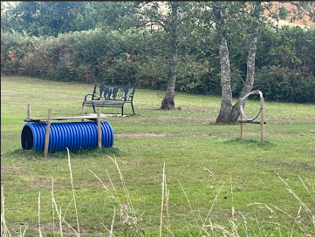  (September 2025)  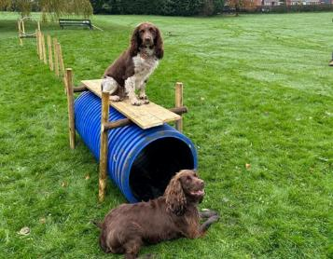  (October 2024, first installed)
9/4 | To approve the cost for repairing the fence at the Triangle | A piece of fence is down at the Hospital Road end of the Triangle where Crane Brook goes under the road.  LDC had been to look at the damaged fence and advised it does need two new posts installing and some new cross members.  Total cost for LDC to supply the replacement parts and undertake the repair would be £175 + vat.  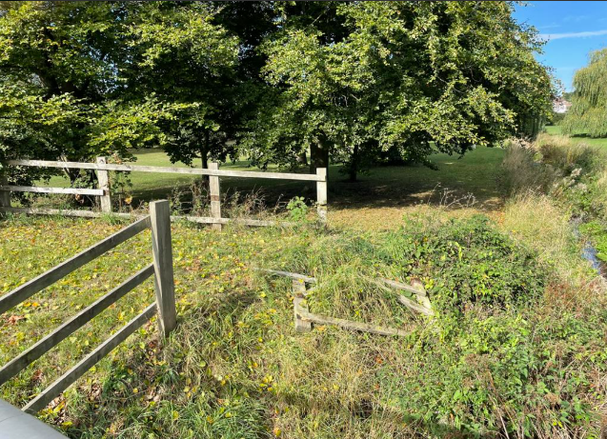
10 | To receive the ROSPA inspection reports for play areas
11 | Correspondence Received and Sent | To be advised separately
12 | Accounts for payment  A report detailing accounts for payment will be circulated before and at the meeting. | To be advised separately

